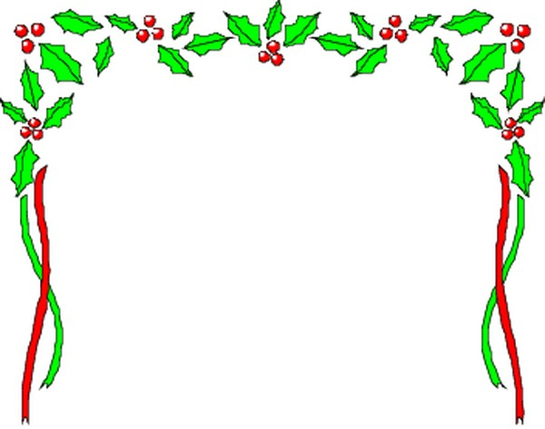

Craft & Gift
FAIR
DEC 10-11
10am-5pm
Over 100 Vendors
Photos with Santa

Smithtown HS East
10 School Street, St James NY 11780

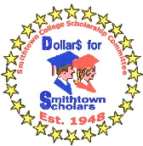
For info 631 846 1459

Sponsored by Smithtown College Scholarship
A committee of Smithtown Council of PTAs
SmithtownCSC@yahoo.com

“Approval for distribution of these materials is not an endorsement of such services, activities and/or products by the Smithtown School District.”

